# Exercise: Working with MS SQL Server LocalDB

This document is a walkthrough through the process of **installing and configuring MS SQL Server 2016 LocalDB (MSSQL LocalDB)**. After following all steps you will have fully installed and configured MSSQL LocalDB and SSMS.

|  |
| --- |
| If you use **old Windows** (e.g. Windows 7 or Windows XP), use **the other lab**, designed for Windows 7 and SQL Server 2014! |

This lab is part of the [“Software Technologies” course @ SoftUni](https://softuni.bg/courses/software-technologies).

# Part I: SQL Server Installation

## Check If You Have LocalDB Already Installed

Open the command prompt (cmd.exe) and run the following command from the console:

|  |
| --- |
| **sqllocaldb versions** |

This command will show you the versions of **LocalDB** that you have already installed:

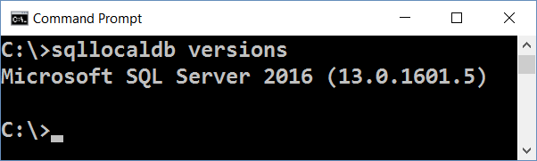

In most cases when you install Visual Studio, it silently installs SQL Server LocalDB as well. The LocalDB version depends on the Visual Studio version. You might have or not have SQL LocalDB.

If you **do not have LocalDB installed**, an **error** like this will be shown:

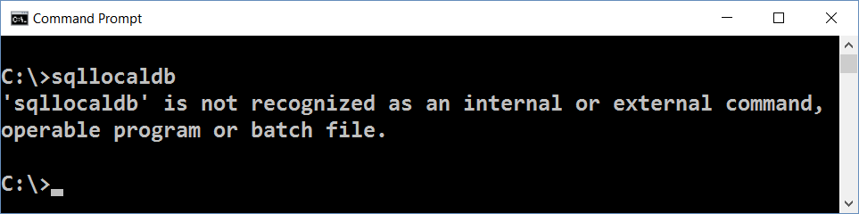

Now you can list the available **LocalDB instances** with this command:

|  |
| --- |
| **sqllocaldb info** |

The **result** should be like at the example below. The list of LocalDB instances could vary depending on your installed software and instances created during the time:

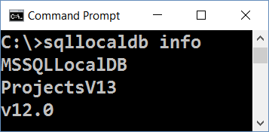

Finally, you can **check the version** and other info for certain instance:

|  |
| --- |
| **sqllocaldb info MSSQLLocalDB** |

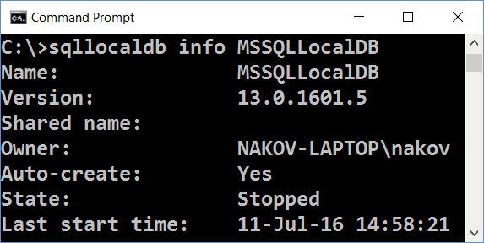

If you have LocalDB installed, skip to SQL Server installation steps. You **don’t need** to install MS SQL Server.

Note that you might have different **versions** of LocalDB in the same time:

* 13.0 means SQL Server 2016
* 12.0 means SQL Server 2014
* 11.0 means SQL Server 2012

Any of the above versions will work correctly for the SQL Server exercises.

### Important Note

|  |
| --- |
| If you **have already installed SQL Server LocalDB** (some version), **you may** **skip the download and install steps** for SQL Server LocalDB. |

## Download MS SQL Server 2016 Express

Download **Microsoft SQL Server 2016 Express** from: <https://www.microsoft.com/en-us/download/details.aspx?id=52679>.

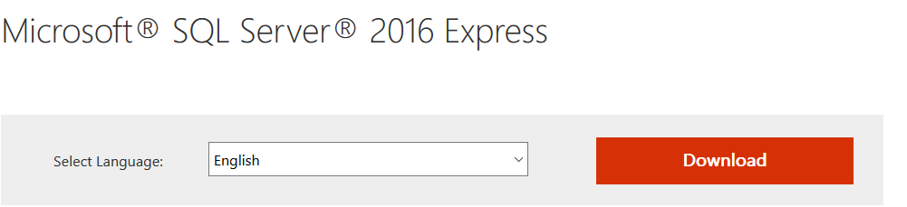

## Install MS SQL Server 2016 LocalDB

In this course we shall use [SQL Server 2016 Express LocalDB](https://msdn.microsoft.com/en-us/library/hh510202.aspx?f=255&MSPPError=-2147217396). This is a lightweight **free** version of SQL Server.

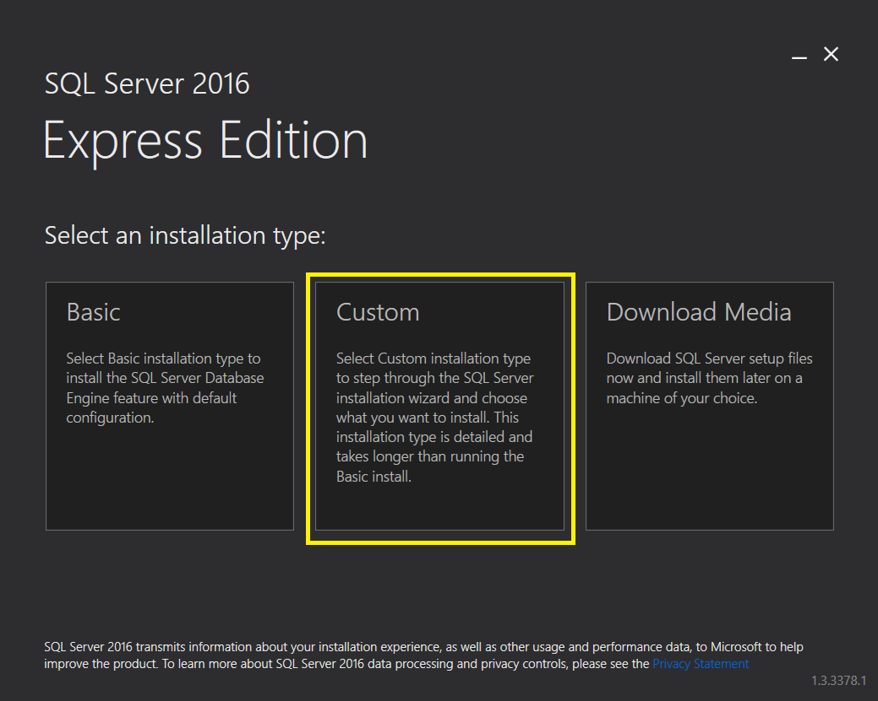

After choosing **Custom** the installer will start the SQL Server Installation Center, that looks like this:

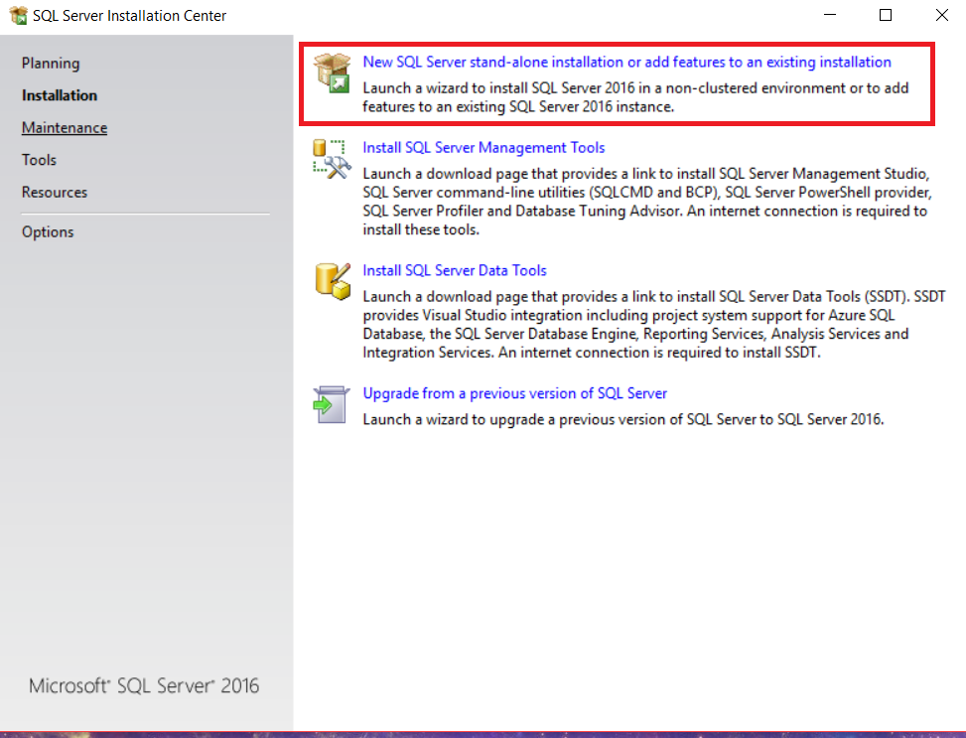

Click on the first option. A new installer will come up. It should look like this:

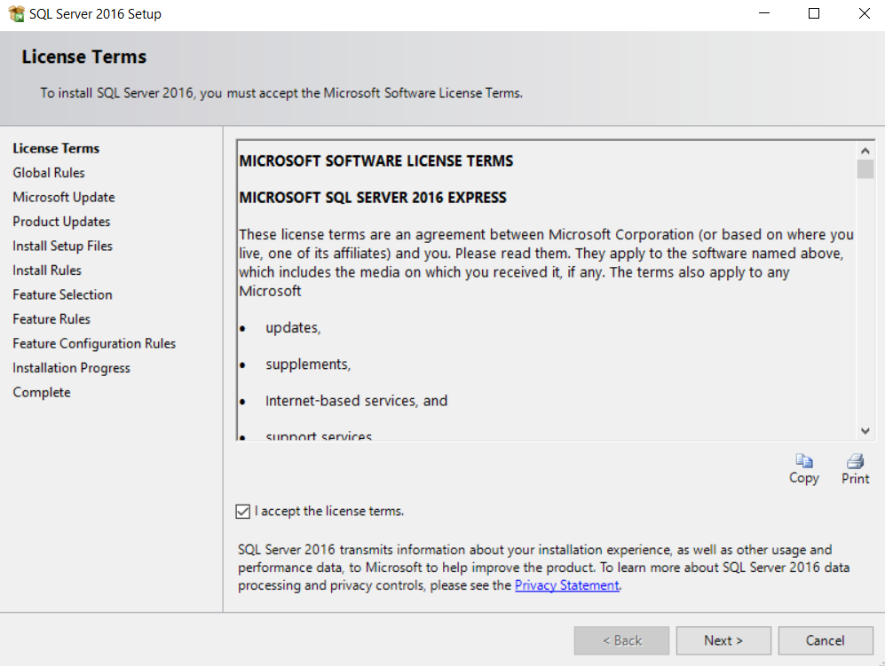

Click [**Next**].

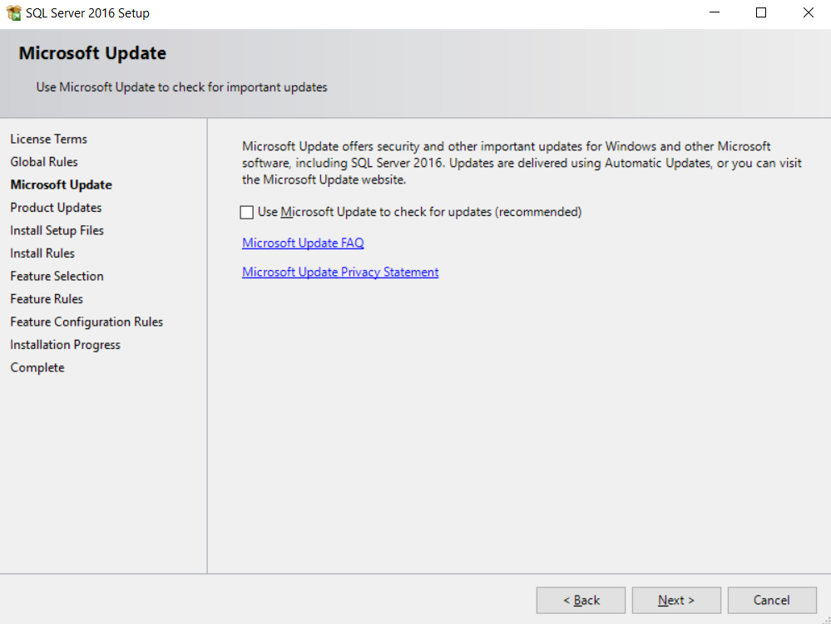

Click [**Next**] again.

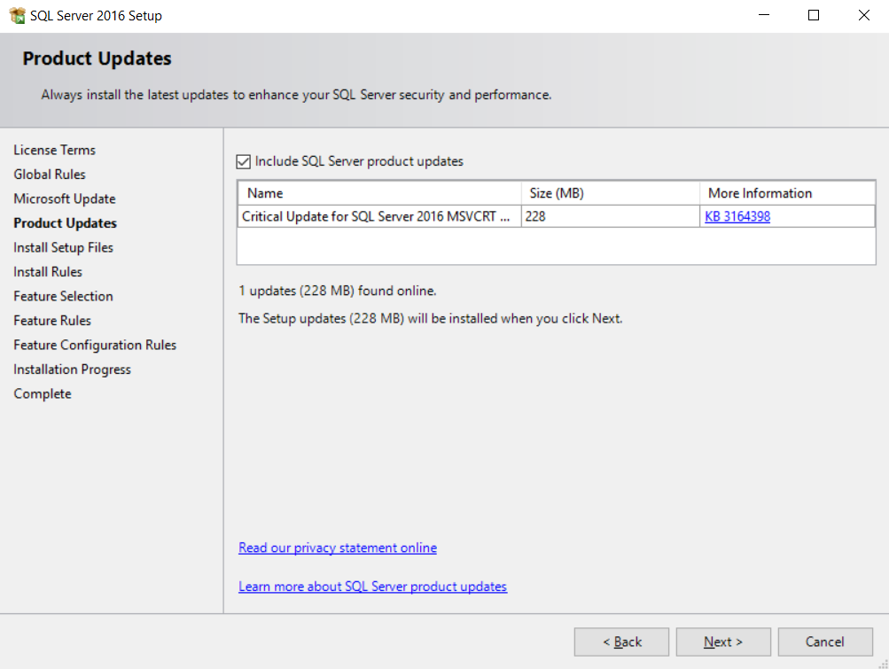

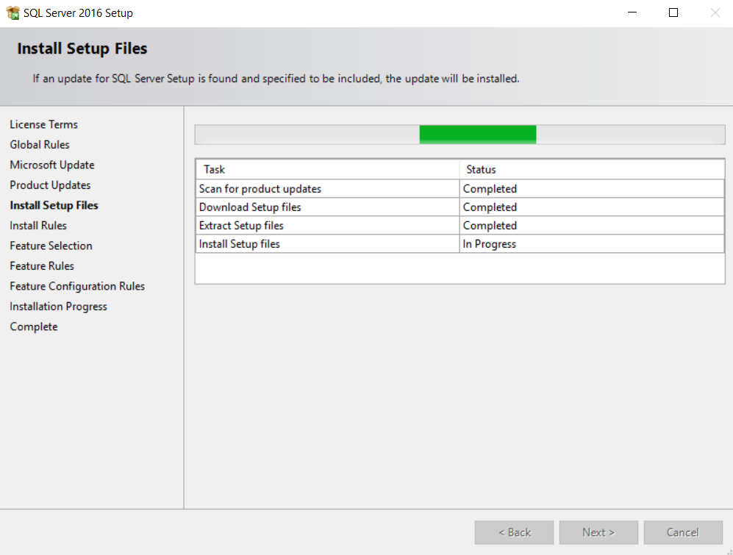

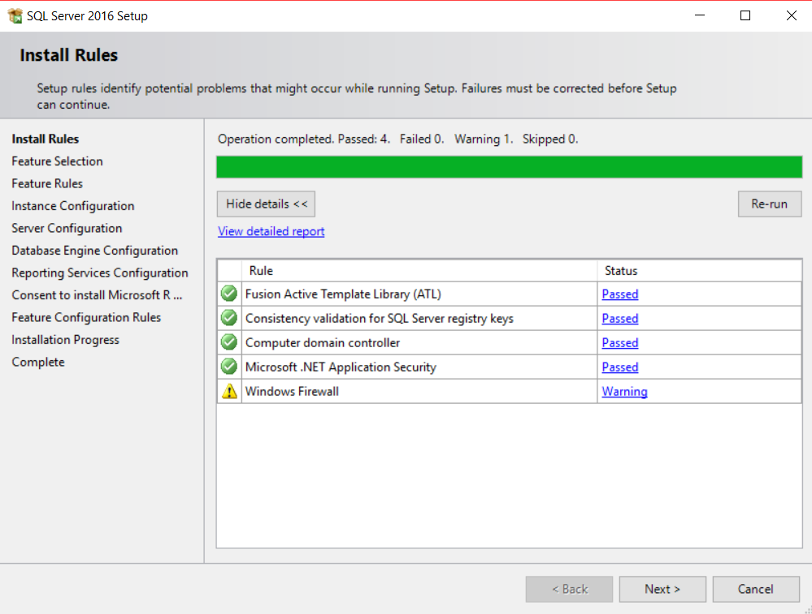

Check the **LocalDB**. It is the only required component for our training course.

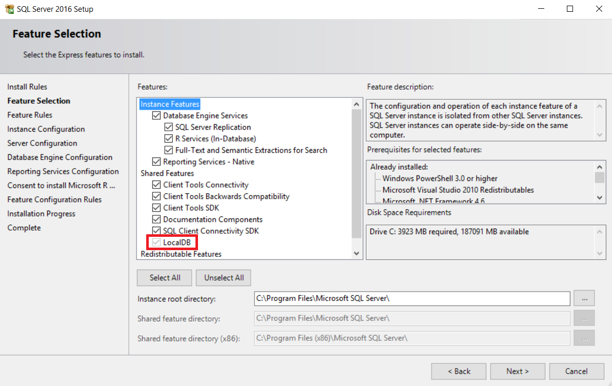

The next few screens will come when you install the full SQL Server Express version (not only the LocalDB):

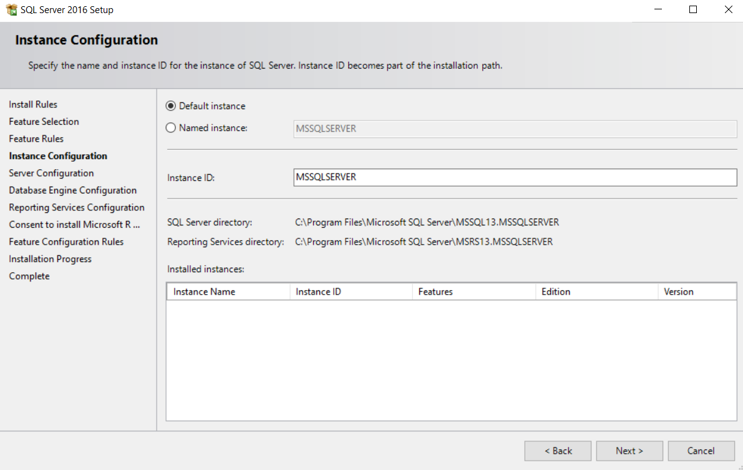

To save memory and Windows startup time, choose **[Manual] Startup Type** for all components.

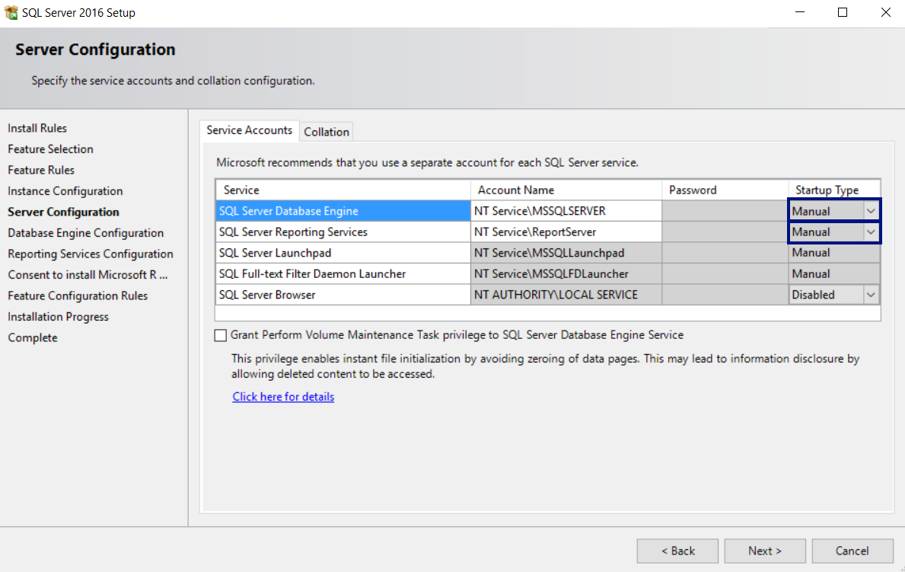

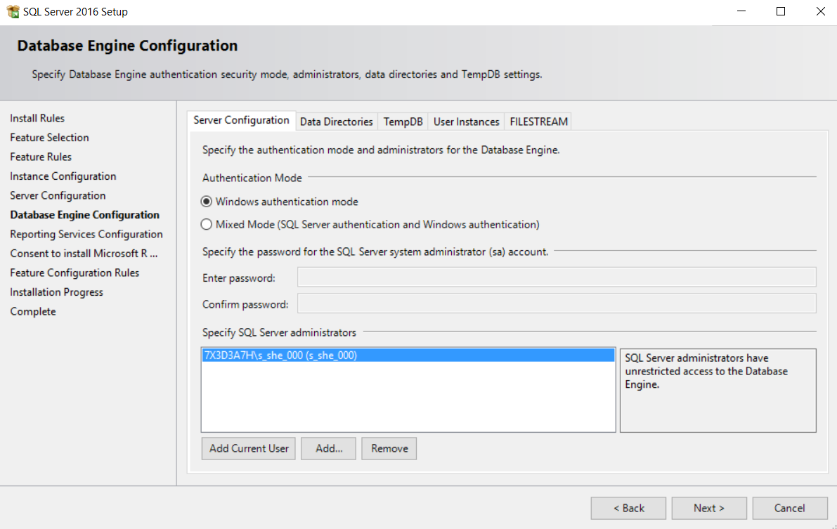

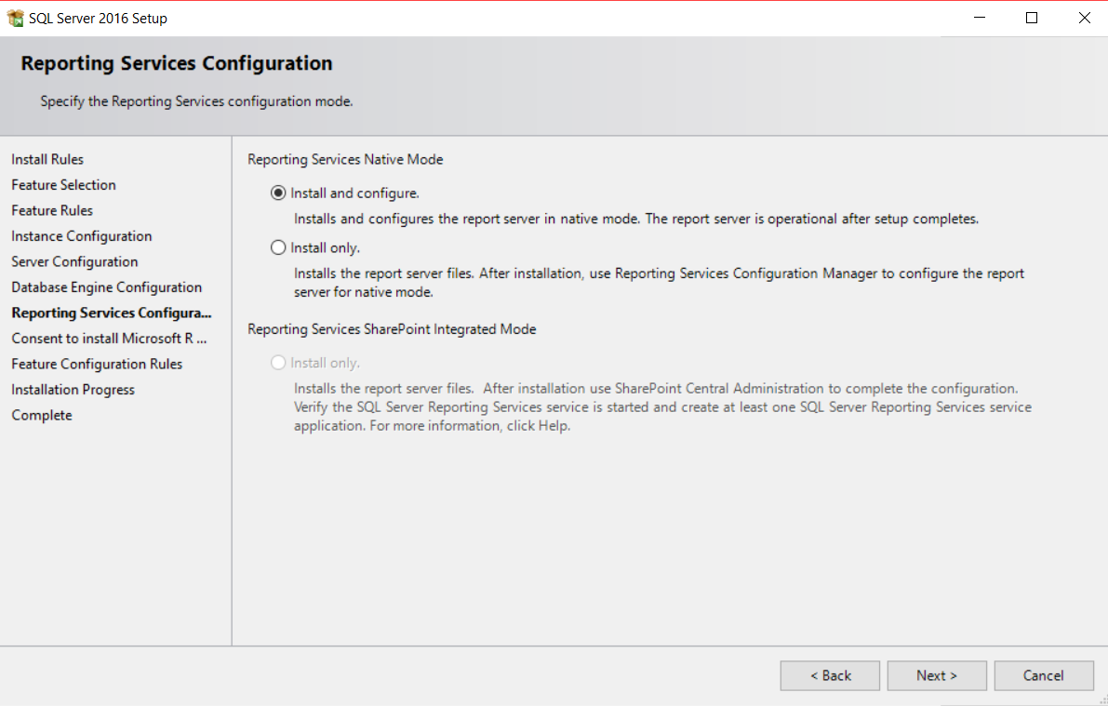

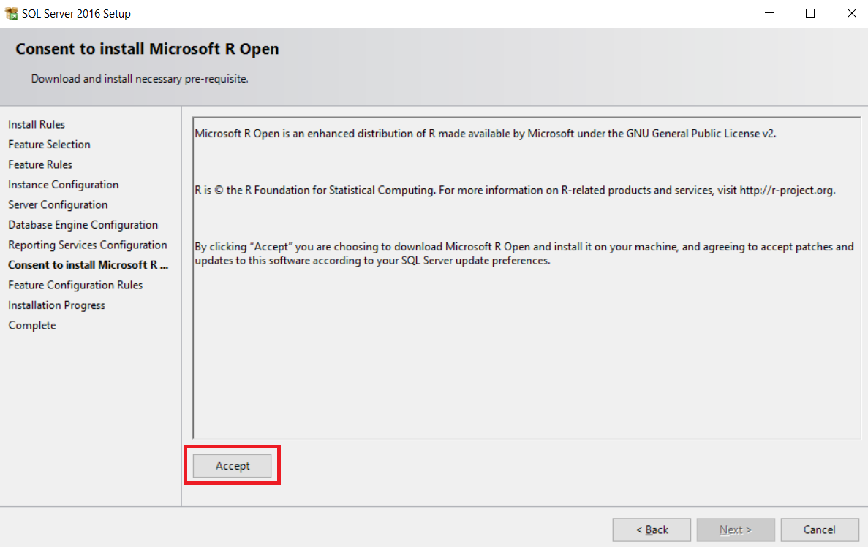

After clicking on **Next** the installation will start.

**Note**: During the installation, you may receive error, which you can simply ignore. It will result in installation fail for the reporting services, but don’t worry, we don’t need them.

That is all, now you have **installed MS SQL Server 2016**.